Protect Your Vehicle Against Catalytic Converter Theft
Catalytic converters are designed to act as a line of defense against harmful exhaust system emissions by turning pollutants into harmless gasses. Thieves target catalytic converters because they contain precious metals, like platinum, palladium, or rhodium, that are valuable to metal dealers. They can sell them to scrap yards for up $200, how are catalytic converters removed?
Thieves typically use a saw or wrench to remove it, depending on whether the catalytic converter is bolted or welded in, and removal can take as little as one minute. So, what can you do to help prevent catalytic converter theft? Read on to learn more about what thieves might be looking for and tips to help protect your vehicle.
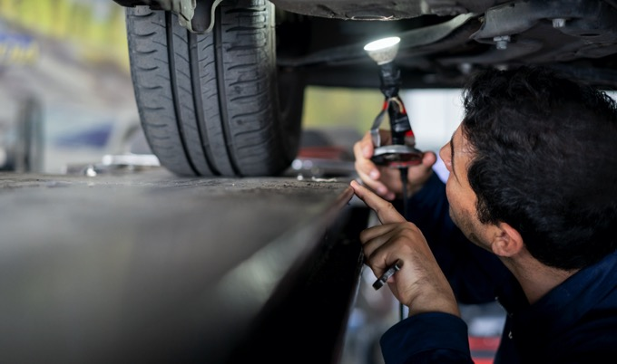

How Do I Know if My Catalytic Converter Was Stolen?
You may not be able to tell your catalytic converter was stolen by looking at your car, but you will know as soon as you start the engine. When the catalytic converter has been removed, your vehicle will make a loud roaring sound that will get louder as you push the gas pedal. Your car might also make a sputtering sound as you change speed, or you'll notice it's not driving smoothly.

What's Being Done to Help Prevent Catalytic Converter Theft?
A victim of theft may spend up to $2,000 getting their vehicle repaired. There are several states trying to help reduce metal theft by instituting laws that regulate scrap metal transactions or dealers, according to the National Conference of State Legislatures (NCSL). Some of these laws may require scrap dealers to document the seller's ID before accepting the metal, or document vehicle descriptions and pictures of the pieces brought in by the scrap seller, says the NCSL.

What Can I Do to Protect My Car's Catalytic Converter?
Consider these tips to help protect your car from catalytic converter theft:
- When possible, park in well-lit areas and close to building entrances.
- If you have a garage at your house, park your car inside and keep the garage door shut.
- Have the catalytic converter welded to your car's frame, which may make it harder to steal.
- Consider engraving your vehicle identification number (VIN) on the catalytic converter — this may help alert a scrap dealer that it was stolen and make it easier to identify the owner.
- Calibrate your car's alarm to set off when it detects vibration.
Understanding when your car might be a target for catalytic converter theft is the first key to preventing it. By following these protective measures, you may help deter thieves from targeting your car

